

**Math Graphing and Calculator App**

**About the Project:** The focus of this study is to ensure that the mobile and web calculation apps are accessible to those with visual impairments and that it is translated into each supported language (Nigerian and Spanish).

**Questions:**

* Is the contrast sufficient to allow those with moderate visual impairment can see the content without additional visual aids?
* Is the content alternative text correctly translated into Spanish?
* Is the content alternative text correctly translated into Nigerian?

**Methodology:**

We used a moderated study design, survey selection, and post-use interview format. No responses were recorded, but answers were instead documented during the interview.

**KPIS: (Key performance indicators)**

* Time on task
* user error rates
* system usability scale
* ease of use of navigation

**Personas**

|  |  |
| --- | --- |
| Shingi Rice (n.d) | **Carla:** As a visually impaired woman I want a more accessible user experience with high-contrast designs that are easy to read so that I can use the site like those without vision impairment.  **Problem:** Carla is a moderately visually impaired student who needs a calculus learning application that uses a high contrast design because neutral colors are difficult for her to see. |
| AntonioDiaz (n.d) | **Shania:** As a Latino American user, I want to have bilingual alternative texts available so that I can share the site with my latino parents.  **Problem:** Shania is a Spanish-Speaking student who needs a calculus learning application that uses Spanish alternative texts because alternative texts help her to better understand the calculations. |
| Carlos David(n.d) | **Rachel:** As an Nigerian-American user, I want to have additional alternative texts available for website content so that I can share the site with my Nigerian parents.  **Problem:** Rachel is a Nigerian-Speaking student who needs a calculus learning application that uses Nigerian alternative texts because alternative texts help her to better understand the calculations. |

**User Journey Map – Visual Impaired**

|  |  |  |  |  |
| --- | --- | --- | --- | --- |
|  | **Access Site** | **Calculate** | **Graph** | **View Resources** |
| **Task list** | Navigate | Enter numbers, calculate answers. | View graphs | Access other resources. |
| **Feeling adjective** | Interested | Inquisitive | Engaged | Curious |
| **Improvement opportunities** | Learn preferences from the user’s engagment. | Learn preferences that distinguish short term users form long term users. | Gain insights from which users access graphing. | Gain insights about which users most often access resources and what resources were accessed. |

**User Journey Map – Spanish Speaking**

|  |  |  |  |  |
| --- | --- | --- | --- | --- |
|  | **Access Site** | **Calculate** | **Graph** | **View Resources** |
| **Task list** | Navigate | Enter numbers, calculate answers. | View graphs | Access other resources. |
| **Feeling adjective** | Interested | Inquisitive | Engaged | Curious |
| **Improvement opportunities** | Learn preferences from the user’s engagment. | Learn preferences that distinguish short term users form long term users. | Gain insights from which users access graphing. | Gain insights about which users most often access resources and what resources were accessed. Gain insights from which language resources are most often used. |

**User Journey Map – Nigerian Speaking**

|  |  |  |  |  |
| --- | --- | --- | --- | --- |
|  | **Access Site** | **Calculate** | **Graph** | **View Resources** |
| **Task list** | Navigate | Enter numbers, calculate answers. | View graphs | Access other resources. |
| **Feeling adjective** | Interested | Inquisitive | Engaged | Curious |
| **Improvement opportunities** | Learn preferences from the user’s engagment. | Learn preferences that distinguish short term users form long term users. | Gain insights from which users access graphing. | Gain insights about which users most often access resources and what resources were accessed. Gain insights from which language resources are most often used. |

**Competitive Audit**

|  |  |  |  |
| --- | --- | --- | --- |
|  | **Strengths** | **Drawbacks** | **Room For Groth** |
| **Desmos** | Strong graphing abitty | Graphing is all that is supported. | Needs more direction and content. |
| **ALEKS** |  | Weak graphing ability. | Needs more instruction and flexibility. |
| **Khan Academy** | Youtube video content | Must pay for many features. | Needs more practice content for students. |

**Moderated Research Plan**

|  |  |
| --- | --- |
| **General Qustion:** | **Example Question** |
| Are users of all languages able to access materials with the alternative text? | Were you able to access the alternative texts in spanish? |
|  | Were you able to access the alternative texts in Nigerian? |
| Are users with moderate visual impairment able to use the site? | Were you able to see the content without additional visual aids? |

**Bottom up Mobile-first Design**

|  |  |  |
| --- | --- | --- |
|  | **Device** | **Dimensions** |
| **Android** | Samsung Galaxy S21. Most common. | 151.7 x 71.2 x 7.9 mm (5.97 x 2.80 x 0.31 in) |
| **Desktop 24”** | Most common. | 1920 x 1080 pixels |
| **Desktop Ultra Wide** | Largest Expected. | 3440 x 1440 |

**Design System Components**

|  |  |
| --- | --- |
| **Component** | **Details** |
| **Typography** | Source Sans 3 |
| **Icons** | Google Material Design Library: ic_calculate, ic_graph, |
| **Animation** | Google Material Design Library: ic_android_launcher_foreground, ic_android_launcher_background, |
| **Colors** | White, Black, Teal, Magenta  "purple_200">#FFBB86FC  “purple_500">#FF6200EE  "purple_700">#FF3700B3  "teal_200">#FF03DAC5  "teal_700">#FF018786  "black">#FFFFFFFF  "white">#FFFFFFFF  “colorPrimary">#FF6200EE  “colorPrimaryDark">#FF3700B3  “colorAccent">#FF018786 |
| **Trigger** | Button Click |
| **Themes** | Theme.MaterialComponents.DayNight.LightActionBar  Base.Theme.Material3.Dark (Preferred for higher contrast) |

**Case Study**

|  |  |
| --- | --- |
|  | **Details** |
| **Introduction** | The focus of this study is to ensure that the mobile and web calculation apps are accessible to those with visual impairments and that it is translated into each supported language (Nigerian and Spanish). |
| **Research Questions** | * Is the contrast sufficient to allow those with moderate visual impairment can see the content without additional visual aids? * Is the content alternative text correctly translated into Spanish? * Is the content alternative text correctly translated into Nigerian? |
| **KPIS (Key performance indicators)** | Key performance indicators include: Time on task, user error rates, system usability scale, use of navigation. |
| **Methodology** | We used a moderated study design, survey selection, and post-use interview format. No responses were recorded, but answers were instead documented during the interview. |
| **Participants** | Cora Adams, Aaron Adams, Shera Adams, Shania, Carla, Rachel. |
| **Target User** | Visually impaired, bilingual, Nigerian, and Spanish-speaking students. |
| **Constraints** | 6-week time constraint, limited budget, single developer / single designer, small team. |
| **Key Insights** | * Darker colors were preferred by those with visual impairment for higher contrast. * Alternative texts were helpful in Spanish. * Alternative texts were helpful in Nigerian. * We also saw improved user engagement measures associated with alternative texts in English comapred with no alternative texts for English users. |

**Low Fidelity Mobile Design**

Samsung Galaxy S21.

151.7 x 71.2 x 7.9 mm (5.97 x 2.80 x 0.31 in)

**Low Fidelity Desktop**

Desktop

1920 x 1080 pixels

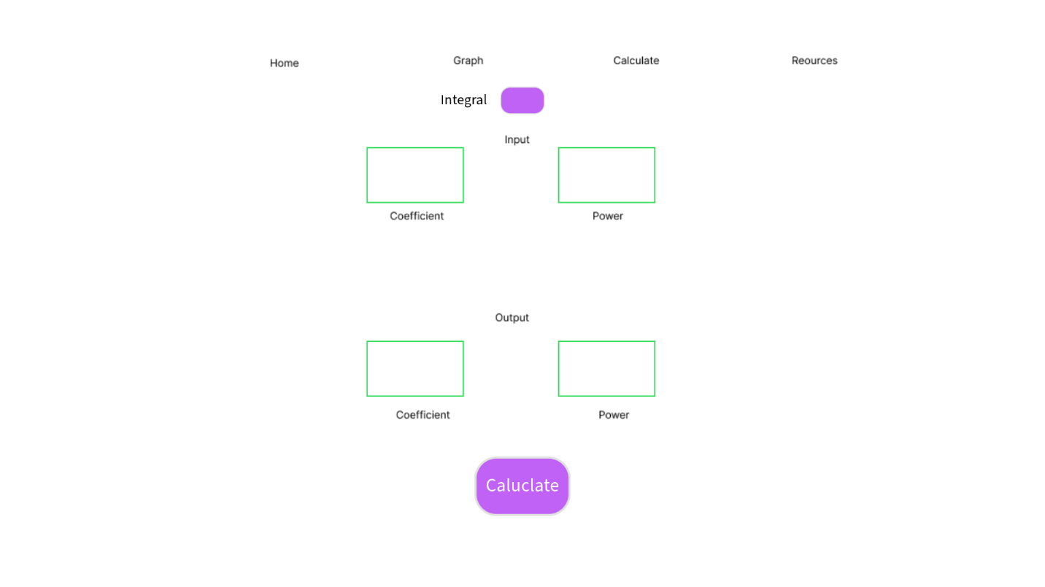

**Post Launch Questionnaires**

|  |  |  |  |  |
| --- | --- | --- | --- | --- |
|  | **Interview Feedback** | **Action** | **Ease of use navigation (scale 1-5)** | **Time on task (scale 1-5)** |
| **Person 1** | Spanish Functionality is good. | No changes needed. | 5 | 5 |
| **Person 2** | Need more visual contrast, prefers darker colors for higher contrast. | Change theme to black background for higher contrast. | 3 | 3 |
| **Person 3** | Nigerian Functionality is good. | No changes needed. | 4 | 5 |
| **Shania** | Spanish Functionality is good. | No changes needed. | 5 | 5 |
| **Carla** | Need more visual contrast, prefers darker colors for higher contrast. | Change theme to black background for higher contrast. | 3 | 3 |
| **Rachel** | Nigerian Functionality is good. | No changes needed. | 4 | 5 |
| **Average** |  |  | 4 | 4.3 |

**Final Mobile App**

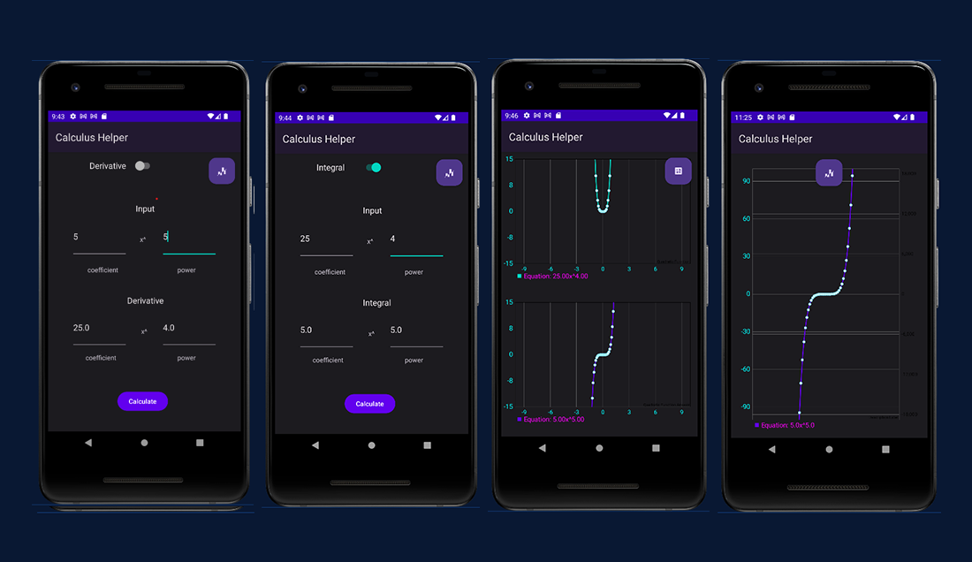

Mobile: [sheraadams/Calculus-Helper-Android-App: Calculus Helper Android App Example (github.com)](https://github.com/sheraadams/Calculus-Helper-Android-App)

**Final Desktop App**

Desktop: [sheraadams/Derivative-and-Integral-Calculator: A derivative and antiderivative calculator for integral calculations and engineering functions to fit mathematical models. (github.com)](https://github.com/sheraadams/Derivative-and-Integral-Calculator)

**References**

Carlos David(n.d) *Young woman with a big smile, isolated on green studio background.*

https://stock.adobe.com/images/young-woman-with-a-big-smile-isolated-on-green-studio-

background/220440238?prev_url=detail

Shingi Rice (n.d) *A portrait of handsome non binary person.* https://stock.adobe.com/images/a-portrait-

of-handsome-non-binary-person/542699470?prev_url=detail

AntonioDiaz (n.d) *Never Stop Smiling Not Even When You're Sad.* https://stock.adobe.com/images/never-

stop-smiling-not-even-when-you-re-sad/258557872